Job name: Feb Pillow Expansion Joint Unit 1
Description: Feb Pillow Expansion joint

Picture  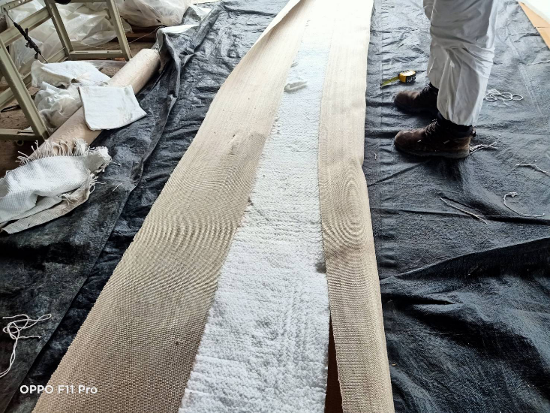 | 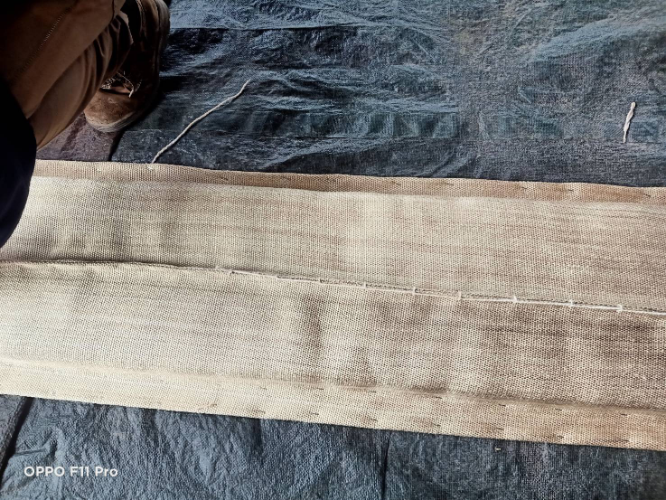
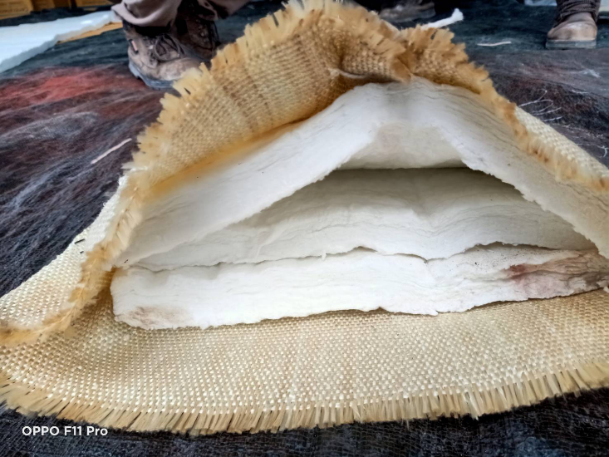 | 
Remark:
Date: 31/07/2023

